Setup document for journals joining Publicera
The objective of this document is to collect all the needed information about a journal to efficiently create a well-functioning website with clear instructions for both authors and reviewers. As soon as the journal’s website is ready, the editors can start using it to accept, review and publish articles.
This document is to be filled out by the journal's editors and/or owners and then shared with KB/Publicera for possible updates and additions. A final version is reviewed by the editors and/or owners, and this version is then the basis for creating the journal's website on Publicera.
Please note that all texts in the document must be proofread as they are intended to be shared publicly. Information about the journal that is published publicly should follow requirements and recommendations from, among others, Directory of Open Access Journals (DOAJ), research funders and publication ethics guidelines.
All fields are mandatory, unless otherwise specified.
Get in touch if you have questions and/or need more information!
Sincerely, the Publicera Group | publicera@kb.se

Part A. Journal information

General information about the journal

 | Title of the journal
 | Volume 2024 |  | What volume number will be published in 2023?
 | Online ISSN |  | If the journal has one.  For newly started journals, KB will help the journal apply for one
 | Print ISSN |  | If the journal has one.  Also note if the journal is no longer published in print
 | Publication frequency online |  | Number of issues per year/volume or continuous publication – articles are published as soon as they are ready and collected in an annual volume.  Specify publication times (e.g. monthly, quarterly, once a year in the fall)
 | Anticipated number of published articles per year and volume |  | Including articles, reviews,  editorials, essays, debates, etc
 | Anticipated number of submitted articles per year and volume |  | Including articles, reviews, debate, editorials, essay, debate, etc
 | Journal's logo |  | Does the journal have a logo?  If so, please email it, in jpeg format, with this document.
 | Journal’s URL |  | It is possible to register or keep your own domain, but this cannot replace the journal's Publicera URL (e.g. https://publicera.kb.se/al)
 | Digital Object Identifiers (DOIs) |  | Does the journal have an existing prefix?  If yes, note the prefix here.  If no, the journal owner/editor will sign a separate agreement with Crossref to obtain a DOI prefix. Publicera assists with the application
 | Abstracting and indexing |  | Which indexes and/or abstracting services, if any, is the journal included in?
 | License and copyright for previously published (archive) articles |  | For archive articles,  what license, if any, was applied (eg CC BY) and who owns the copyright? If this has changed over time, please note what license and copyright conditions applied for which years/volumes.
 | Sales print |  | Is the journal sold in print? If so, by whom and at what price?
 | Article/Publication Fees |  | Amount, per page/article - or if you do not charge or intend to charge fees, note this with text such as e.g. "The journal does not charge any publication fees."
 | Waivers/vouchers |  | If there are publication fees, add a text describing your policy for who waivers and vouchers, according to guidelines from research funders
 | The journal's advertisement/sponsorship policy |  | Does the journal accept advertisements and/or sponsorships? Is there a policy for what kinds of advertisers, etc.? Provide a contact name and email for questions about ads.
 | The journal's funding |  | Support from various research councils, support from the university/department, the association, membership fees, print subscriptions, advertisements, article fees, etc. Sources of income will be indicated on the journal's website.

Launch and license

 | Desired date for the journal's launch on Publicera? |  | This will also depend on  resources at KB.
 | CC license | CC BY  CC BY-SA  CC BY-NC  CC BY-NC-SA | Choose one of these four.  See https://www.kb.se/samverkan-och-utveckling/oppen-tillgang-och-bibsamkonsortiet/open-access-and-bibsam-consortium/open-access/creative-commons-faq-for-researchers.html and  https://chooser-beta.creativecommons.org/ for more information about the licenses and help choosing one.

Aims & scope, editorial team, etc.

The following texts will be available on the journal's website. Feel free to look at and draw inspiration from other journals on Publicera, adapting/editing the texts to suit your journal. The recommendations of DOAJ, research financiers and universities, among others were used as a basis for the information requested below.
 | Brief description of the journal |  | Max 250 words, posted on the journal's home page and used in other contexts as a basic description
 | Description of the journal for search engines |  | 50-300 characters including spaces. This may be a shorter version of the text above
 | Keywords |  | Indicate the subject area of the journal; enter at least five, separated by commas
 | Social Media |  | If the journal has social media accounts and you want to add links to Twitter, Facebook, etc., provide the account names
 | The journal's Aims & Scope |  | Describe the journal's (for example) content, objectives, subject areas, selection criteria, article types and history. No limitation in length, but feel free to structure with subheadings and/or bulleted lists.
 | The journal's intended readership
 | The journal's owner |  | Association/foundation/institution etc. Enter name, address, URL if applicable
 | Owner's organization number
 | Contact person for the owner |  | Name, phone, address, e-mail, possible institution
 | The journal's editor-in-chief |  | Name, title, institution/university, city, country, e-mail
 | Editorial contact |  | If someone other than the editor-in-chief, e.g. a shared email box
 | Editorial mailing address |  | Full postal address for the editorial team/office
 | Support contact |  | This contact helps editors, authors and reviewers with any problems they may have in submitting, editing or reviewing articles. Enter name, title, institution/university, city, country, e-mail
 | Editorial secretary |  | If relevant. Enter name, title, department/university, city, country, e-mail
 | Co-editors/assistant editors |  | If relevant. Enter name, title, department/university, city, country, e-mail
 | Editorial committee |  | If relevant. This refers to the group that decides on the journal's policy, focus, finances, etc. Owners and editors are often represented in such a group. Enter names, institution/university, city, country.
 | Editorial board |  | If relevant. Often a group of experts within the journal's subject area who can contribute with advice for the journal's development, show the journal's regional and/or international anchoring, etc. Where applicable, editorial board members also contribute with expert review  (see also description here ).  Note that some indexes require a journal to have an editorial board  Enter names, institution/university, city, country

Author Instructions

The editors must attach author instructions. The text should include a clear statement of the copyright policy and author/publication fee policy.

The instructions do not have to be sent with this document, but should be provided at the latest when we begin building the journal's website. Please see this document for guidance on what should be included in author instructions: https://publicera.kb.se/ps/article/view/7957

Settings for OJS (Open Journal Systems)

These settings will be made before the editors are given access to the system. Many of the settings can be changed afterwards as necessary - except primary language.
However, we recommend that the editors agree on the various parameters as early as possible in the setup process.
 | Primary language for interface and instructions (not for manuscripts) | Swedish or English | Choose one
 | Secondary language for interface and instructions (not for manuscripts) | Swedish or English | If relevant. Please note that all instructions and descriptions (sections 3 and 4 above) must be provided in both the primary and secondary languages if used
 | Language in which articles are published |  | Specify all languages in which you accept manuscripts
 | Type of peer review | 1. Anonymous author (single-blind)  2. Anonymous author and reviewer (double-blind)  3. Open peer-review  4. Other | Specify the review procedure that will be used in the journal
 | Standard period for responding to an invitation to review a manuscript | X weeks | Enter approximate time, in number of weeks
 | Default automatic review invitation reminder period | X days after the deadline | Enter the approximate time, in days, after the deadline
 | Standard period for reviewers to submit their comments | X weeks | Enter approximate time in number of weeks
 | Default automatic reminder period to submit review comments | X days after the deadline | If a reviewer agreed to contribute comments but did not submit them; enter approximate time in number of days after the deadline has passed

Sections in the journal
It is important to provide information to authors about the type of articles that the journal's editors accept and whether there are special conditions that apply to each type of article.
The information below will form the basis of the settings in the system. Each section can have its own requirements and parameters, and different sections can be assigned to different editors.
It should also be clearly mentioned in the author instructions which conditions apply to each section.
Feel free to add your own article types and remove those that are not relevant.
TYPE OF ARTICLE | Original article
Abbreviation in the system | ART
Peer reviewed  choose an alternative |  | Yes or no
Mandatory to provide abstract  choose an alternative |  | Yes or no
Max. number of words in abstract  Select an option and enter the number of words |  | Yes or no  If yes, max # words
Is the section open to all authors to submit to or is it for editorial use? *see below |  | Specify editor or all
Responsible editor |  | If specific person, otherwise leave blank
Publication fee |  | If relevant

* Select open for authors or for editorial use.
This refers to whether authors should be able to submit a manuscript to the section. Most sections are open to authors, but editorials can, for example, be a section that is only for editorial use. Sections open to authors will appear in the drop-down menu of the form authors use when submitting a manuscript:
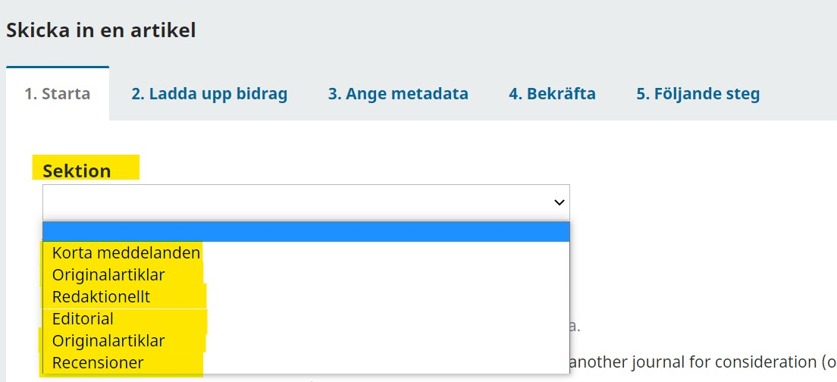

TYPE OF ITEM | Review
Abbreviation in the system | REV
Peer reviewed  choose an alternative |  | Yes or no
Mandatory to provide abstract  choose an alternative |  | Yes or no
Max. number of words in abstract  choose an alternative |  | Yes or no  If yes, specify max # of words
Is the section open to all authors to submit to or is it for editorial use? *see above |  | Specify editor or all
Responsible editor |  | If specific person, otherwise leave blank
Publication fee |  | If relevant

Part B. Plugins in OJS
In OJS (Open Journal Systems) there are many functions that are operated with the help of various plugins. The list below shows which plugins will be activated by default when you start using Publicera's platform and are needed for the basic functions.

Installed plugins by default
- DOI plugin: Enables assignment of Digital Object Identifiers to articles
- Google Scholar Indexing Plugin: Enables indexing of published content in Google Scholar
- Plugin for static pages: Makes it possible to create custom pages in submenus
- "Submit Submission" block: Creates a button in the right column of the website that authors can click to go directly to the article submission form
- Custom Blocks: Allows you to add, edit and remove custom sidebar blocks
- Citation Style Language plugin: Enables readers to view a published article's citation in multiple formats
- PDF Viewer: Displays the PDF in a separate tab in the browser

Optional plugins
Listed below are some useful functions that can be activated as needed. Please check the box to the right of the optional plugins you would like installed.
Plugins | Choice  (Mark an X to activate)
Language selector block
Allows users to change the language of the interface; needed if the website is to have instructions and descriptions in two languages
Matomo
GDPR-compliant web analytics plugin that collects data on the number of unique visitors to the journal's website (something funders may request in funding applications)
Keyword cloud block
Creates a clickable and searchable word cloud in the right column, based on the keywords of the published articles; see example: https://publicera.kb.se/sjpa
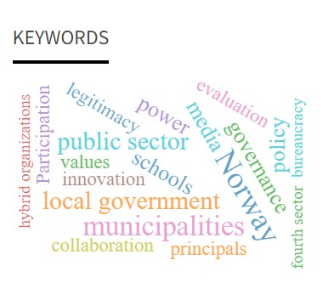
Browse block
Displays a menu in the right column where the user can browse between the journal's different categories of articles. ATTENTION - this requires careful planning of categorization; see example: https://publicera.kb.se/tfl
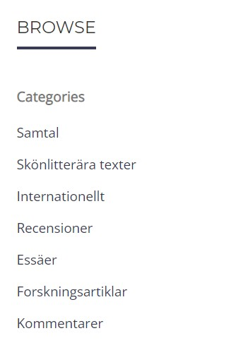
Recommend Similar Articles plugin
Adds recommended further reading in the journal on the articles' web pages, under the abstract.

Recommend articles by the same author plugin
Inserts a list of articles by the same author on the article's abstract page, see example: https://publicera.kb.se/mosp/article/view/12223
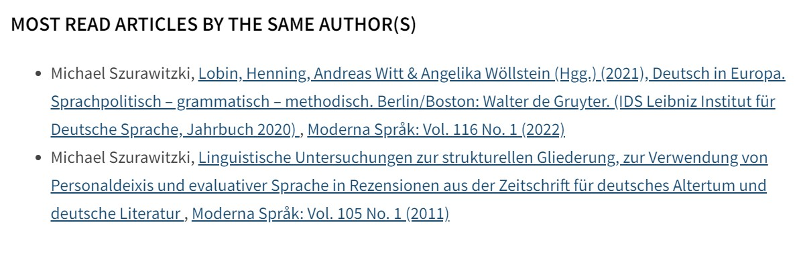
eLife Lens viewer for articles
Displays XML files in reading view in a separate tab in the browser. Creates navigation between headings and between images/graphs/tables and links up reference lists. For an example, click on the XML button for an article in this journal: https://publicera.kb.se/tgv
JATSParser plugin
Displays the article in full text on the first article page in the system (ie the reader does not need to click and/or download to read). Based on the XML file
Texture editor plugin
Enables editors to create and edit manuscript XML files in Word format

Part C. Policy texts
The following policy texts are based on recommendations for principles of transparency and best practice from The Committee on Publication Ethics (COPE), Directory of Open Access Journals (DOAJ), the Open Access Scholarly Publishing Association (OASPA), and the World Association of Medical Editors (WAME).
Adapt/edit so that the texts fit your journal. Feel free to use track changes so that we can see if you have edited these texts.
These texts are also available in Swedish.

Open access policy
[Sample text. Add information specific to your journal.]
All published content in [journal name] is published with immediate open access, which means that you as a user do not need to pay or register to read content.
Subscription to the print edition of the journal costs [X].
Authors of content published in [journal name] retain copyright to their works. Articles are published under the terms of a Creative Commons license [CC BY XX] , which permits use, downloading, distribution, linking to, and reproduction in any medium, provided the original work is properly cited. For contents of volumes X – X, [these terms applied] . License and copyright information is provided on each article.
[Journal Name] does not charge author or publication fees.
Authors are encouraged to deposit the final published version of their article for self-archiving (author's personal website) and/or archiving in an institutional archive immediately after publication.

Editorial policy
Describe how the peer-review process works, whether it is anonymized or not, whether there is an initial selection, etc. Please see guidelines from VR and Uppsala University here: https://codex.uu.se/forskarens-etik/att-publishera / and policy questions to consider here https://doaj.org/apply/transparency/
[Sample text, feel free to edit]
All submitted manuscripts are first assessed by an editor who decides whether the manuscript is suitable to be sent for peer review.
Manuscripts deemed suitable for further review are sent to two or more experts who are tasked with highlighting the manuscript's general and specific merits and shortcomings.
The journal uses a single-blind/double-blind review procedure before acceptance/rejection of manuscripts, which means that authors and reviewers are anonymous throughout the review process.
The review process is expected to take 6 to 8 weeks but may vary.
Based on the review, the editor then compiles a recommendation to a) accept the manuscript for publication b) ask the author to revise the manuscript or c) reject the manuscript.
The overall publishing responsibility rests with the journal's editor-in-chief, who has a qualified editorial board for support in various issues regarding the publication of individual manuscripts, the journal's development, etc.
Original articles and XX articles are externally peer-reviewed, but debate, essays and book reviews are approved by the editors without external peer review.
In cases where a manuscript’s author is in some way associated with the editorial team, they will be removed from all editorial tasks for that article. An independent editor will be tasked with organizing the peer-review process. The author's affiliation with the journal will also be indicated in the final publication of the article.
The journal accepts manuscripts that have previously been uploaded for review as preliminary versions, on personal websites, presented at conferences, or made available through other informal communication channels. However, authors must hold copyright for the text in question. Authors are also encouraged, when available, to include links to previous versions of the article in the final version of the article published in the journal.
Duplicate publication, also called "redundant publication" or "dual publication", is not permitted. This refers to the publication of the same article in more than one journal or to the publication of a document that is substantially similar to one already published without reference to the original publication.

Authorship Policy
[Sample text, feel free to edit]
Each author, and any co-authors, must meet the following criteria:
1. All must have made a significant contribution to the design of the study, the collection of data, or the analysis and interpretation of data;
2. All must, either by writing or by helping to edit the manuscript, have contributed to the design of its intellectual content to a significant degree;
3. All must have approved the submitted manuscript.
Each author must also be able to take responsibility for part of the article's content and be able to identify which co-authors are responsible for the remaining parts.
Those who do not meet these criteria but who nevertheless contributed significantly to the final manuscript should be included in the acknowledgments section. It is the author's responsibility to obtain the written approval of persons named in the acknowledgments section.
The text above comes from CODEX - rules and guidelines for research.

3.1 Policy on the use of AI tools
[Journal editors are encouraged to formulate a policy addressing the use of AI tools in submitted manuscripts. These policies may differ based on the academic discipline and the unique perspective of each journal. Provided below is a sample text, which may provide a starting point for the development of your journal's policy. We recommend that when formulating your journal's policy, you review policies, statements, and recommendations provided by reputable organisations such as the International Committee of Medical Journal Editors (ICMJE), the Committee on Publication Ethics (COPE), and the World Association of Medical Editors (WAME). It may also be helpful to read how others have formulated their guidelines for responsible use of AI.]
[Sample text; edit to suit your journal]
In accordance with COPE’s position statement on the use of artificial intelligence (AI) tools, AI tools such as Large Language Models, chatbots and image creators cannot be credited with authorship of any manuscript submitted to this journal. Authorship attribution implies responsibility for the integrity, originality, accuracy and validity of a work, and AI tools cannot take such responsibility.
In any instance where generative AI tools have been employed in the creation of written content, generation of images or graphical elements, or the collection and analysis of data within a submitted work, authors are required to disclose these uses within the manuscript. This acknowledgement should provide explicit information about the specific tasks performed by AI tools, including the identification of the tool(s) and their respective versions. AI tools used to improve or correct spelling and grammar need not be credited.
Authors bear full responsibility for the content of their manuscript, including any portions generated with the assistance of AI tools. Consequently, they are liable for any potential breaches of publication ethics. Authors must ensure that all quoted and referenced material is appropriately credited.

Policy for peer reviewers
[Example text, feel free to edit ]
Authors of manuscripts and reviewers of the same manuscript must not be close colleagues, family members, work on the same research project, or otherwise have a close collaboration.
Reviewers should only accept to assess manuscripts that fall within their own subject area.
Reviewers should respond to invitations without delay and submit completed reviews within a reasonable time.
Reviewers' comments must not be influenced by the author's nationality, religious or political beliefs, gender or commercial interests.
Reviewers' comments must not contain hostile or provocative language and must not include personal attacks, slander or other derogatory comments.

Policy for open data
[Sample text, feel free to edit]
As research funders' and universities' demands for open research data become increasingly common, some authors may be required to make their collected empirical material open and available to everyone.
In cases where this applies to the journal's authors, the journal's editors encourage making the data available according to the FAIR principles (Findable, Accessible, Interoperable, Reusable).
In that case, the material made available must be linked to within the submitted manuscript under a special heading. Research data should then be made public when the article is published. Empirical material obtained from other researchers must be referenced in the same way as other scientific sources. For further questions about guidelines for handling open data and guidelines about how data should be handled and published, please contact your university.

Archiving policy
[Sample text, feel free to edit]
Beginning when the journal joins Publicera, its current and future content is made available via Publicera and stored long-term on a secure and central server at the National Library of Sweden (KB).
The journal's owner and KB aim for the journal's archive to be transferred and made available via Publicera, and thus the archive will also be stored long-term on a secure and central server at KB. In the event that the journal ceases publishing, the journal's content on Publicera will remain archived at KB.

Policy for self-archiving
[Sample text, feel free to edit]
Article authors have the right to self-archive the submitted ("preprint") version of the manuscript and the published version without any embargo period.
Submitted manuscripts and published versions of articles can, for example, be archived on:
• the author's personal website
• the author's company website and/or institutional repository or archive
• non-profit preprint servers or subject-based archives

Policy for the use of ORCiD
[Sample text, feel free to edit]
The journal's editors strongly recommend that authors who submit manuscripts register an "Open Researcher and Contributor Identifier" or ORCiD.
This registration provides a unique and stable digital author identity that ensures that the article is attributed to the correct person and improves the searchability of all the author's publications. This helps to ensure that the author receives recognition for their work. As a person's ORCiD remains the same as long as the account exists, any name changes, change of employment, department affiliation or research field do not affect the searchability of previous publications. This facilitates correspondence between research colleagues.
The journal's editors encourage all authors to include ORCiD along with other author information when the manuscript is registered in the system. If the article is accepted, this will be published with the article.

Policy for previous versions of articles
[Sample text, feel free to edit]
The journal's editors allow authors to make available earlier drafts of manuscripts/articles on the condition that authors agree to the following:
Authors retain all rights to any previously published version and are permitted to submit their updated manuscript to the journal.
Authors accept that the journal's editors cannot guarantee full anonymity in the review process, even if the author anonymizes his manuscript when earlier versions of the manuscript are made available.
If the manuscript is published in the journal, the author is expected to cross-link, with DOI link, the different versions of the manuscript/article.

Policy for changes and corrections of published material and discussion after publication
[Sample text, feel free to edit]
The conditions of publication with persistent identifiers such as DOIs include that the object published is final and not changed without readers being clearly informing of this.
Articles published in the journal cannot therefore be changed without a) an erratum or b) a change notice being published and linked to the original article.
If a factual error in an article is discovered, this should be reported to the editor-in-chief, who decides on possible actions and possible corrections.
[optional, omit if not applicable]
The journal encourages post-publication discussion through letters to the editor or on an externally moderated site for review and discussion of post-publication research, such as PubPeer.

Complaints and Appeals Policy
[Sample text, feel free to edit]
In the case of formal complaints, disputes, or appeals, authors should contact the editor-in-chief, who is responsible for ensuring that a fair, deliberative, and thorough investigation is conducted.

Policy for ethical oversight
[Sample text, feel free to edit]
The journal follows the ethical guidelines and best practices set forth by the Committee on Publication Ethics (COPE). All cases of ethical misconduct will be handled in accordance with COPE's recommendations and guidelines.

Part D. Author Checklist for Manuscript Submission
The terms and conditions below will be publicly visible on the journal's website. See, for example, https://publicera.kb.se/tfl/about/submissions.
Authors submitting manuscripts must read and agree to the terms and conditions before proceeding to fill in metadata and upload files.
It is fine to add or remove items from the list as suits the journal, or to fine-tune the language (in that case use track changes in the text below). Where a [LINK] is indicated, it will be possible to click on to the journal's more detailed instructions.

I, the submitting author, warrant that, where applicable, I have the permission of all co-authors to submit this version of the manuscript according to the journal's criteria for authorship [LINK] and to be their spokesperson during the review process and beyond. I also approve distribution with the CC license the journal uses, and this too has been approved by co-authors.
All authors of the manuscript are qualified to be considered as such, in accordance with the guidelines set forth in criteria for authorship [LINK] and all have given their permission to be credited in the submitted manuscript. Anyone who contributed to the work that does not meet the criteria for authorship is listed in the Acknowledgments section.
The manuscript has not been previously published in the current submitted version, nor is it under consideration by another journal. If the manuscript has been published in an earlier version, this should be clearly indicated; see the journal's editorial guidelines [LINK]. (Feel free to enter an explanation in the box "Comments to the editor" if relevant).
The submitting author has entered their ORCiD identification number in their author data. Any co-authors have been advised to also provide one in accordance with journal policy [LINK].
All material presented in the manuscript where copyright is held by third parties has been properly produced and necessary permissions have been obtained by the submitting author.
The text follows the stylistic and bibliographic requirements specified in the author instructions [LINK].
The manuscript files uploaded for review are anonymized according to journal policy [LINK].
All individuals or groups of individuals who can be identified in a study, or their guardians, have signed informed consent documents, thereby giving their consent for the submitted manuscript to be published under a CC license.
Where applicable, the research has been reviewed by an appropriate ethics committee and the name of the committee and approval reference number included in the submitted manuscript.

The association or the editor-in-chief are themselves responsible for registering and maintaining the external domain. KB is not responsible for the operation or connection to external domains. However, external domains can be pointed to Publish in order to create a separate identity for the journal online.
The editor-in-chief is also responsible for personal data for the journal, and thus complete information needs to be noted in this document. The journal's owner is responsible for appointing the editor-in-chief. We recommend that there is an agreement between the owner and the editor-in-chief regarding the distribution of responsibilities, tasks, possible compensation, etc.

